CST Bulk Email Insufficiency Handling

Scope: CST email bulk insufficiency fulfillment workflow — automating intake, document segregation, and candidate/check grouping, up to handoff into the single email handling pipeline (built separately).
What We Are Automating
- Reading and parsing bulk insufficiency emails received from the Email Review System (ERS)
- Downloading all attachments, files, and linked documents referenced in the email
- Segregating and grouping documents into one folder per candidate (by ARS number, Check ID, Emp ID, or Candidate Name)
- Handing off each candidate's folder to the existing single email handling pipeline
Not automated in this phase: document content validation, data correction in Bridge, and case closure — these remain manual (Steps 3-6 below) until later phases.
Formats We Handle
- Excel sheet (ARS number, Check ID, Emp ID, or Candidate Name)
- ZIP, RAR, 7z archives, including nested archives
- Google Drive links, SharePoint links, direct file/ZIP links
- Email body content (tables or plain text with candidate details)
- .eml / .msg (forwarded emails as attachments)
- Loose document attachments: PDF, PNG, JPG, JPEG, DOCX, TIFF, HEIC
- Excel alone, with no documents (insuff info such as UAN present directly in the sheet)
- Email body alone, with no documents (candidate info typed directly in the email)
Current Manual Flow
Step 1 — Intake CST receives from CSE via email.
Inputs: ex:
- Excel sheet
- Documents folder or folder link Formats supported: ZIP, Drive, Email body (tables or attachments), SharePoint, .eml, etc Excel usually contains: ARS number or Check ID or some unique identifier.
Step 2 — Candidate / Check Resolution CST takes Excel and documents, uses the ARS or Check ID to search in Bridge, and opens: Case → Check → Open Insufficiency.
Step 3 — Validation + Correction CST locates candidate documents in the folder, then manually:
- Opens the document
- Validates against Bridge fields
- Corrects wrong values if required
- Enters missing values if needed
- Overwrites allowed fields CST is doing both document validation and data completion.
Step 4 — Commenting After each action, CST updates comments. Comments are mandatory for audit, insufficiency history, and traceability.
Step 5 — Fulfillment CST fulfills at the check level. Result: Check → Fulfilled.
Step 6 — Case Closure Rule: If all check insufficiencies are completed, the case is closed. Otherwise, the case remains open.
Implementation Flow (What We Are Building)
Step 1 — Email Parser Agent
Input: Bulk email from ERS
Action: Parses the email, reads the content, downloads the files, attachments, and links Output: Email content, files attached
Step 2 — Segregation and Grouping Agent
Input: Files, folders, email content from Step 1
Action: Segregation and grouping
Output: Separate folder for each ARS or Check ID or Emp ID or Candidate Name
Step 3 — Single Email Handling Pipeline (already being built)
Input: Folder from Step 2
Action: Searches the ARS or whatever is available on the folder name, downloads the docs, classification, OCR, etc
Output: Comment generation
Note Step 3 is a separate, already in-progress workstream. This document covers Steps 1-2 only — bulk email to per-candidate folder.

INPUT ACTION OUTPUT
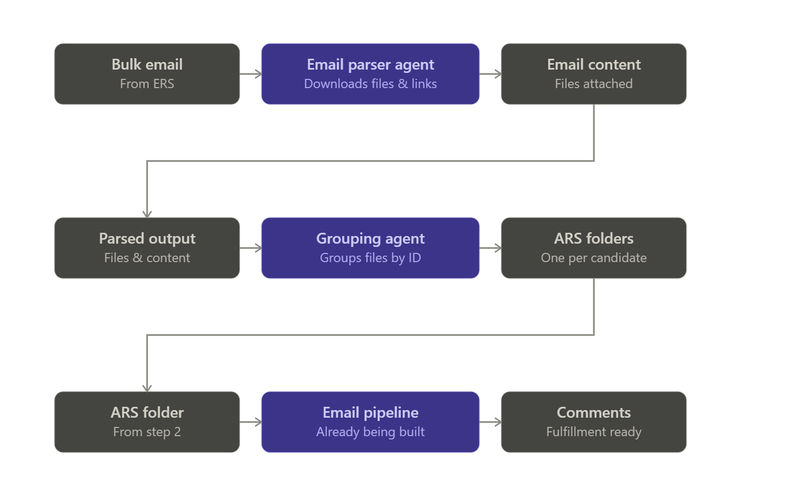

Gemini API Cost Overview
Estimated costs using Google Gemini 2.5 Flash · $0.30 input / $2.50 output per 1M tokens.
Monthly Emails Processed | Avg. Docs per Email | Est. Monthly Cost (USD) | Est. Monthly Cost (INR)
100 emails / month | ~30 docs | ~$1.20 | ~₹102
100 emails / month | ~100 docs | ~$2.80 | ~₹238
300 emails / month | ~100 docs | ~$8.40 | ~₹714
500 emails / month | ~80 docs | ~$11.50 | ~₹978
1,000 emails / month | ~200 docs | ~$55.00 | ~₹4,675
Cost scales with document count, not email count. A single email with 500 documents costs more than 50 emails with 10 documents each.

Table 2 — AI Step Breakdown (per Email)
Step | What It Does | Est. Cost per Email | Main Cost Driver
Email Classification | Reads subject, body, and attachment names — identifies Excel sheets, ZIPs, Drive links, and any candidate data written in the email body | ~$0.001 | Thread length
Excel Column Mapping | Reads the first rows of the candidate spreadsheet and maps columns (ARS, Name, Check ID, etc.) — runs once per Excel, regardless of row count | ~$0.001 | Column count
Document Grouping | Matches every extracted file to the right candidate using folder names, file names, and IDs — this is the main cost driver | $0.005 –$0.12 | File count ▲
Total per email |  | $0.007 –$0.12
All three steps use Google Gemini 2.5 Flash. Extraction, file copying, and output assembly run in Python at zero API cost.

